**CHAPTER ONE**

**1.0 Introduction**

**1.1 General Overview**

Supermarket management system is the system where all the aspects related to the proper management of supermarket is done. These aspects involve managing information about the various products, staff, managers, customers, billing etc. This system provides an efficient way of managing the supermarket information. Also allows the customer to purchase and pay for the items purchased.

This project is based on the sales transaction and billing of items in a supermarket. The first activity is based on adding the items to the system along with the rate which are present in the supermarket and the name of the items which the supermarket will agree to sell. This authority is given only to admin (administrator). Any modifications to be done in the item name and the rate can be done only by admin. He also has the right to delete any item. As the customer buys the products and comes to the billing counter, the user is supposed to enter the item name he purchased and the quantity of the item he had purchased. This is not a huge a task.

This study is to produce software which manages the sales activity done in a supermarket, maintaining the stock details, maintaining the records of the sales done for a particular month/year. The users will consume less time in calculation and the sales activity will be completed within a fraction of seconds whereas manual system will make the user to write it down which is a long procedure and so paper work will be reduced and the user can spend more time on the monitoring the supermarket. The project will be user friendly and easy to use.

The system will display all the items whose name starts with the letter selected by the user. He can select out of those displayed. Finally a separate bill will be generated for each customer. This will be saved in the database. Any periodic records can be viewed at any time. If the stock is not available, the supermarket orders and buys from a prescribed vendor. The amount will be paid by deducting the total amount acquired in the sales activity. Admin provides a unique username and password for each employee through which he can login.

**1.1.2 The Modules of Operation is stated below**

**Account Configuration:**

**Employee:** When a new employee joins the company, his record is saved in the database.

**Items:** Here the Admin can add any new items present in the supermarket. He also has the right to modify or delete it from the database.

**Registration:** As soon as the employee joins the company, the admin provides unique username and password to him.

**Vendor Order:** If the stock is not available, the supermarket orders and buys from a prescribed vendor. The amount will be paid by deducting the total amount acquired in the sales activity.

**Stock entry:** The items bought from the vendor will be entered here and this will be added to the stock.

**Indent Report:** This provides the report of the items sold for a particular month/ year and also gives the total amount acquired.

**Vendor Report:** This provides the report of the items bought from a vendor for a particular month/ year and also gives the total amount spent.

**Display:** A user can view information regarding Items present in the supermarket.

**Logout:** This module allows the user to Logout the application. Further operations cannot be performed after user exits.

**FUNCTIONS OF THIS SYSTEM:**

1. This system provides list of various products

2. There are various brands information along with the additional details

3. There is online application form where customer can choose their respective product.

4. There is one important functions provided where the information about the staff can be maintained.

5. There is database connectivity provided where each customer detail has been stored.

6. The system Provide functions of editing customer details.

7. Its Provide functions of editing product details.

8. Its Provide functions of editing staff details.

1.2 **Statement of Problem**

Being a Computer Technology student we had to go into the business department to learn some basic sales and supermarket management topics to increase our intellectual understanding on the project at hand it was really tasking.

Building a standard Supermarket management system was not an easy task looking at the problems of existing manual system

The factors for these difficulties are:

1. **Time Consumption:** Manual systems are time consuming, as the business owner must keep track of Supermarket sales on a daily basis, while updating the system manually at the end of the day.

2. **Poor Communication:** A manual Supermarket system requires employees and managers to write down each time an item is removed from the Supermarket. If one employee forgets to mention that the last coffee product has been removed from the Supermarket, a manager expects the item to still be available for a customer during a sale. Compared with a technical Supermarket system, a manual Supermarket system does not help the communication in the workplace.

3. **Physical Counts:** A manual Supermarket system does not provide any number, as all numbers from the Supermarket are gained through physical Supermarket counts. One of the difficulties of running a manual Supermarket system is that physical Supermarket counts must be performed frequently to control the items in the Supermarket. This is time consuming and can cost the business money, if employees must come in to help out outside of business hours.

4. **Daily Purchases:** Keeping track of daily purchases is another difficult controlling measure with manual Supermarket systems. A manual Supermarket system requires the employees to write down the items sold during a single work day. This can be a difficult task, as one employee may lose the list of items sold or another may forget to write down a sale.

5. **Ordering Supplies:** A manual Supermarket system does not update at the end of the day with updated Supermarket

**1.3 Aims and Objective of Study**

**Aim of study is**

To design a Computerized Supermarket Management System to ascertain stock level of a supermarket, when to order for more goods, keep status and updates of transactions, thereby helping progress level, stock taking and managerial decisions,.

**The objective are**

1. To study the functions of Supermarket management system.

2. To explore the challenges being faced by the manual system.

3. To make a software fast in processing, with good user interface.

4.To ensure accurate statistics of product item.

5. For Easy record of goods in store and proper identification.

**1.3 Scope of Study**

This research work covers stock control, management and tends to correct anomalies in Supermarket business. It analyses opening of new stocks, stock updates and ability to view existing ones. It provides quick way of operation by capturing the manual process and automating them. This project is helpful to computerize the item transaction, sales activity record keeping which is a very huge task and maintaining the stock

**1.4 Limitation of Study**

Due to time and basic factors like unstable electricity, poor networks, unavailability of concrete business idea and many more this research has been limited to certain areas in supermarket management we only looked more into the supermarket inventory management area using Microsoft access and Visual basic.

**1.5 Definition of Terms**

**MODULES:** This can be described a search of a set of standardized parts or independent units that can be used to construct a more complex structure, such as an item.

**ADMIN:** This isthe administration of a business, organization,

**USERNAME:** This is an identification used by a person with access to a computer, network, or online service.

**PASSWORD:** This isa secret word or phrase that must be used to gain admission to a place.

**VENDOR ORDER:**This isa commercial document used to request someone to supply something in return for payment and providing specifications and quantities;

**INDENT REPORT:** This contains[Order](http://www.businessdictionary.com/definition/order.html) for [goods](http://www.businessdictionary.com/definition/goods.html) (placed often through a local or foreign [agent](http://www.businessdictionary.com/definition/agent.html) of a foreign [supplier](http://www.businessdictionary.com/definition/supplier.html)) under specified  [conditions](http://www.businessdictionary.com/definition/condition.html) of [sale](http://www.businessdictionary.com/definition/sale.html), the [acceptance](http://www.businessdictionary.com/definition/acceptance.html) of which by the supplier (or the agent) constitutes a [contract of sale](http://www.businessdictionary.com/definition/contract-of-sale.html).  
**MICROSOFT VISUAL BASIC:** Visual Basic is a third-generation event-driven programming language and integrated development environment from Microsoft for its COM programming model first released in 1991.

**MICROSOFT ACCESS:** Microsoft Access, also known as Microsoft Office Access, is a database management system from Microsoft that combines the relational Microsoft Jet Database Engine with a graphical user interface and software-development tool.

**CHAPTER TWO**

**2.0 LITERATURE REVIEW**

**2.1 Introduction to Supermarket**

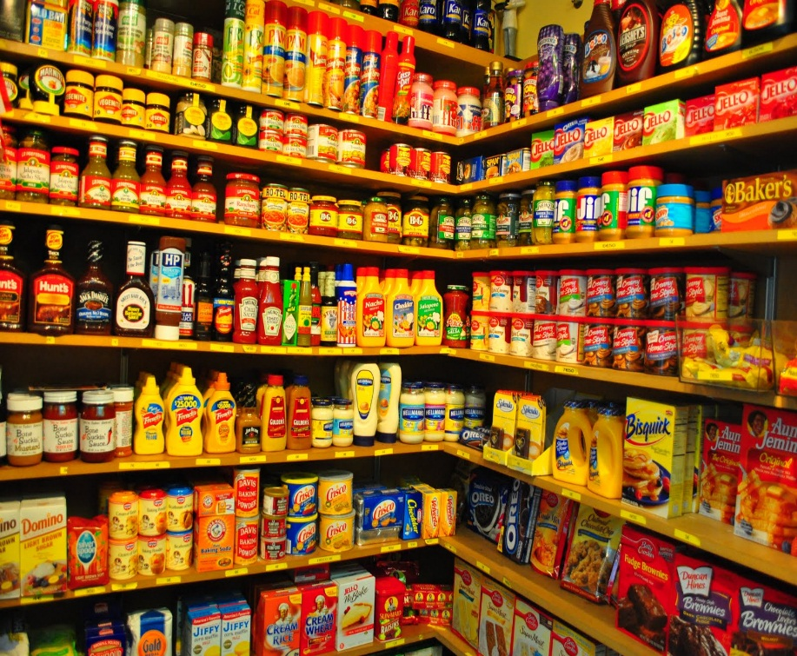A supermarket is a large form of the traditional [grocery store](http://en.wikipedia.org/wiki/Grocery_store), it is a [self-service](http://en.wikipedia.org/wiki/Self-service) [shop](http://en.wikipedia.org/wiki/Retail#Types_of_retail_outlets) offering a wide variety of [food](http://en.wikipedia.org/wiki/Food) and household products, organized into aisles. It is larger in size and has a wider selection than a traditional grocery store, but is smaller and more limited in the range of merchandise than a [hypermarket](http://en.wikipedia.org/wiki/Hypermarket) or big-box market.

The concept of an inexpensive food market relying on large economies of scale was developed by [Vincent Astor](http://en.wikipedia.org/wiki/Vincent_Astor). He founded the Astor Market in 1915, investing $750,000 of his fortune into a 165 by 125 corner of in the famous 95 [Manhattan](http://en.wikipedia.org/wiki/Manhattan) avenue, creating in effect, an open air mini-mall that sold meat, fruit, produce and [flowers](http://www.loc.gov/pictures/resource/cph.3c06967/). The expectation was that customers would come from great distances ("miles around"), but in the end even attracting people from ten blocks away was difficult, and the market folded in 1917. The concept of a super market was developed by [entrepreneur](http://en.wikipedia.org/wiki/Entrepreneur) [Clarence Saunders](http://en.wikipedia.org/wiki/Clarence_Saunders_(grocer)) and his [Piggly Wiggly](http://en.wikipedia.org/wiki/Piggly_Wiggly)stores. His first store opened in 1916. Saunders was awarded a number of [patents](http://en.wikipedia.org/wiki/Patent) for the ideas he incorporated into his stores. The stores were a financial success and Saunders began to offer franchises. [The Great Atlantic & Pacific Tea Company](http://en.wikipedia.org/wiki/The_Great_Atlantic_%26_Pacific_Tea_Company), which was established in 1859, was another successful early grocery store chain in [Canada](http://en.wikipedia.org/wiki/Canada) and the United States, and became common in North American cities in the 1920s. The general trend in retail since then has been to stock shelves at night so that customers, the following day, can obtain their own goods and bring them to the front of the store to pay for them. Although there is a higher risk of [shoplifting](http://en.wikipedia.org/wiki/Shoplifting), the costs of appropriate security measures ideally 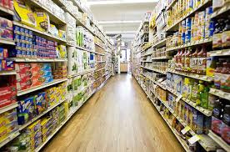will be outweighed by reduced labor cost.

Historically, there was debate about the origin of the supermarket, with King Kullen and [Ralphs](http://en.wikipedia.org/wiki/Ralphs) of [California](http://en.wikipedia.org/wiki/California) having strong claims. Other contenders included Weingarten's Big Food Markets and Henke & Pillot. To end the debate, the [Food Marketing Institute](http://en.wikipedia.org/wiki/Food_Marketing_Institute) in conjunction with the [Smithsonian Institution](http://en.wikipedia.org/wiki/Smithsonian_Institution) and with funding from [H.J. Heinz](http://en.wikipedia.org/wiki/H.J._Heinz), researched the issue. It defined the attributes of a supermarket as "self-service, separate product departments, discount pricing, marketing and volume selling."

It has been determined that the first true supermarket in the United States was opened by a former [Kroger](http://en.wikipedia.org/wiki/Kroger) employee, [Michael J. Cullen](http://en.wikipedia.org/wiki/Michael_J._Cullen), on August 4, 1930, inside a 6,000-square-foot (560 m2) former garage in [Jamaica, Queens](http://en.wikipedia.org/wiki/Jamaica,_Queens) in [New York City](http://en.wikipedia.org/wiki/New_York_City). The store, [King Kullen](http://en.wikipedia.org/wiki/King_Kullen), (inspired by the fictional character [King Kong](http://en.wikipedia.org/wiki/King_Kong)), operated under the slogan "Pile it high. Sell it low." At the time of Cullen's death in 1936, there were seventeen King Kullen stores in operation. Although Saunders had brought the world self-service, uniform stores and nationwide marketing, Cullen built on this idea by adding separate food departments, selling large volumes of food at discount prices and adding a parking lot.

Other established American grocery chains in the 1930s, such as Kroger and [Safeway](http://en.wikipedia.org/wiki/Safeway_Inc.) at first resisted Cullen's idea, but eventually were forced to build their own supermarkets as the economy sank into the [Great Depression](http://en.wikipedia.org/wiki/Great_Depression), while consumers were becoming price-sensitive at a level never experienced before. Kroger took the idea one step further and pioneered the first supermarket surrounded on all four sides by a [parking lot](http://en.wikipedia.org/wiki/Parking_lot).

Supermarkets proliferated across Canada and the United States with the growth of automobile ownership and [suburban development](http://en.wikipedia.org/wiki/Suburb) after [World War II](http://en.wikipedia.org/wiki/World_War_II). Most North American supermarkets are located in suburban [strip shopping centers](http://en.wikipedia.org/w/index.php?title=Strip_shopping_center&action=edit&redlink=1) as an anchor store along with other smaller retailers. They are generally regional rather than national in their company [branding](http://en.wikipedia.org/wiki/Brand). Kroger is perhaps the most nationally oriented supermarket chain in the United States but it has preserved most of its regional brands, including [Ralphs](http://en.wikipedia.org/wiki/Ralphs), [City Market](http://en.wikipedia.org/wiki/King_Soopers#City_Market), [King Soopers](http://en.wikipedia.org/wiki/King_Soopers#King_Soopers), [Fry's](http://en.wikipedia.org/wiki/Fry%27s_Food_and_Drug), [Smith's](http://en.wikipedia.org/wiki/Smith%27s_Food_and_Drug), and [QFC](http://en.wikipedia.org/wiki/QFC).

In Canada, the largest such chain is [Loblaw](http://en.wikipedia.org/wiki/Loblaw_Companies), which operates stores under a variety of regional names, including [Fortinos](http://en.wikipedia.org/wiki/Fortinos), [Zehrs](http://en.wikipedia.org/wiki/Zehrs), [No Frills](http://en.wikipedia.org/wiki/No_Frills_(grocery_store)), the Real Canadian Superstore, and the largest, [Loblaws](http://en.wikipedia.org/wiki/Loblaws), (named after the company itself). [Sobeys](http://en.wikipedia.org/wiki/Sobeys) is Canada's second largest supermarket with locations across the country, operating under many banners (Sobeys IGA in [Quebec](http://en.wikipedia.org/wiki/Quebec)). Québec's first supermarket opened in 1934 in Montréal, under the banner [Steinberg's](http://en.wikipedia.org/wiki/Steinberg%27s).

In the United Kingdom, self-service shopping took longer to become established. Even in 1947, there were just ten self-service shops in the country. In 1951, ex-[US Navy](http://en.wikipedia.org/wiki/US_Navy) sailor Patrick Galvani, son-in-law of [Express Dairies](http://en.wikipedia.org/wiki/Express_Dairies) chairman, made a pitch to the board to open a chain of supermarkets across the country. The UK's first supermarket under the new [Premier Supermarkets](http://en.wikipedia.org/wiki/Premier_Supermarkets) brand opened in [Streatham](http://en.wikipedia.org/wiki/Streatham), [South London](http://en.wikipedia.org/wiki/South_London), taking ten times as much per week as the average British general store of the time. Other chains caught on, and after Galvani lost out to Tesco's [Jack Cohen](http://en.wikipedia.org/wiki/Jack_Cohen_(businessman)) in 1960 to buy the 212 Irwin's chain, the sector underwent a large amount of consolidation, resulting in 'the big four' dominant UK retailers of today: [Tesco](http://en.wikipedia.org/wiki/Tesco), [Asda](http://en.wikipedia.org/wiki/Asda) (owned by [Wal-Mart](http://en.wikipedia.org/wiki/Wal-Mart)), [Sainsbury's](http://en.wikipedia.org/wiki/Sainsbury%27s) and [Morrisons](http://en.wikipedia.org/wiki/Morrisons).

In the 1950s, supermarkets frequently issued [trading stamps](http://en.wikipedia.org/wiki/Trading_stamp) as incentives to customers. Today, most chains issue store-specific "membership cards," "club cards," or "[loyalty cards](http://en.wikipedia.org/wiki/Loyalty_card)". These typically enable the card holder to receive special members-only discounts on certain items when the credit card-like device is scanned at check-out. Sales of selected data generated by club cards is becoming a significant revenue stream for some supermarkets.

**2.2 Types of Supermarket**

Supermarket is categorized into different type due to their size, scale, products offered, Store Format and TrendsWhile people use the terms "Grocery Store", ”Hypermarket” and "Bigboxmarket" interchangeably to refer to retail food stores, industry watchers offer more specific guidelines about different types of Supermarket. "Hypermarkets" are on the larger end of this spectrum and carry a diverse mix of food and general merchandise. Nomenclature is not always uniform Financial Institutions Fund places Wal-Mart in the same category as supermarkets, but accounting for only the supercenter's grocery division. The Food Marketing Institute classifies superstores as a large type of supermarket, while designating warehouse stores as grocery stores.

**Grocery Store:**A grocery store is a [retail store](http://en.wikipedia.org/wiki/Retail_store) that primarily sells [food](http://en.wikipedia.org/wiki/Food). A grocer is a bulk seller of [food](http://en.wikipedia.org/wiki/Food). Grocery stores often offer non-perishable food, with some also having fresh produce, butchers, delis, and bakeries. Large grocery stores that stock significant amounts of non-food products, such as clothing and household items, are called [supermarkets](http://en.wikipedia.org/wiki/Supermarket). Some large supermarkets also include a pharmacy and an electronics section, the latter selling DVDs, headphones, digital alarm clocks, and similar items. Grocery stores operate in many different styles ranging from rural family-owned operations, such as [IGAs](http://en.wikipedia.org/wiki/IGA_(supermarkets)), boutique chains, such as [Whole Foods Market](http://en.wikipedia.org/wiki/Whole_Foods_Market) and [Trader Joe's](http://en.wikipedia.org/wiki/Trader_Joe%27s) to larger supermarket chain stores. In some places, [food cooperatives](http://en.wikipedia.org/wiki/Food_cooperative) or "co-op" markets, owned by their own shoppers, have been popular. However, there has recently been a trend towards larger stores serving larger geographic areas.

**Hypermarket:** Is an advanced [supermarket](http://en.wikipedia.org/wiki/Supermarket) which has an additional [department store](http://en.wikipedia.org/wiki/Department_store). The result is an expansive[retail](http://en.wikipedia.org/wiki/Retailing) facility carrying a wide range of products under one roof, including full [groceries](http://en.wikipedia.org/wiki/Grocery_store) lines and [general merchandise](http://en.wikipedia.org/wiki/Product_(business)). In theory, hypermarkets allow customers to satisfy all their routine shopping needs in one trip. After the successes of super-markets and hyper-markets and amid fears that smaller stores would be forced out of business, franchise laws that made it more difficult to build hypermarkets and also restricted the amount of economic leverage that hypermarket chains can impose upon their suppliers. In France, hypermarkets are generally situated in [shopping centers](http://en.wikipedia.org/wiki/Shopping_mall) ([French](http://en.wikipedia.org/wiki/French_language): *centre commercial or centre d'achats*) outside of cities, though some are present in the city center. They are surrounded by extensive car parking facilities, and generally by other specialized [superstores](http://en.wikipedia.org/wiki/Superstores) that sell clothing, sports gear, automotive items, etc.

**Bigboxmarket:**Is a physically large retail establishment, usually part of a chain. The term sometimes also refers, by extension, to the company that operates the store. The store may sell general [dry goods](http://en.wikipedia.org/wiki/Dry_goods),it is generally inaccessible to pedestrians and often can only be reached by motor vehicles, the big-box store is regarded as unsustainable and a failure of [urban planning](http://en.wikipedia.org/wiki/Urban_planning).

Some conservatives worry about the economic impact of big-box retailers on established [downtown](http://en.wikipedia.org/wiki/Downtown) merchants or the [sprawl](http://en.wikipedia.org/wiki/Urban_sprawl)-inducing impacts on the character of such developments, as these stores are often associated with heavy traffic in the areas around the store locations. Some communities have adopted a higher level of architectural treatment and regulations to ensure that the superstores relate better to their environs and neighbors. Many regulate signage and landscaping.

There are also concerns surrounding traffic and roads. The increased traffic leads to more air pollution in an area and higher taxes in order to maintain the roads.

**2.3 Introduction to Online marketing (E-Commerce)**

The internet marketing has been active for a long time now, the cumulative events occurring in online marketing is leading up to where we are now it have impacted the entire globe faster than any marketing revolution in history.

Over the past decade or so, supermarkets and other grocery retailers have continued to invest significantly into broadening their Internet presence and expanding the number of channels through which their goods are sold. Key Note estimates that sales of groceries transacted via online channels observed double-digit growth between 2007 and 2011, increasing by 127% overall.

One of the major trends to have driven growth within the Internet grocery market is m-commerce that is sales made via mobile channels, i.e. smart phones and tablet computers. The increasing popularity of smart phones and tablets among consumers has resulted in a whole host of retailers investing significant sums of money into mobile sales platforms, as well as downloadable applications (apps'), which offer a more interactive and personalized shopping experience.

Despite the growth of online grocers in recent years, online spending still accounts for a relatively small proportion of the overall Internet grocery market, with just 3.9% of total grocery sales estimated to have been transacted via e-commerce and m-commerce channels. However, the share of the total grocery market represented by online grocers has continued to increase year-on-year since at least 2007, when their market share stood at just 2.1%.

Key Note expects the Internet grocery market to continue to go from strength to strength over the forthcoming years and has forecast year-on-year double-digit growth for 2012 to 2016. The rising uptake of Internet-connected mobile devices, such as smart phones and tablets, should boost sales transacted via m-commerce channels, while continued Government investment in the rollout of superfast broadband, alongside the introduction of the UK's first 4G mobile network, will also help to boost Internet activity and the use of e-commerce services throughout the country.

Online marketing can broadly be defined as the processes or areas involved in the running and operation of an organization that are electronic or digital in nature. These include direct business activities such as marketing, sales and human resource management but also indirect activities such as business process re-engineering and change management, which impact on the improvement in efficiency and integration of business processes and activities.

In 1994, spending for internet marketing totaled nearly nothing, but increased to over $300 million in 1995. Now, little more than a decade later, marketing spending and internet marketing business has exploded to nearly $200 billion (according to [Forrester Research](http://www.shop.org/c/journal_articles/view_article_content?groupId=1&articleId=702&version=1.0)). Today, it’s hard to believe in having an organization which doesn’t have some kind of online presence.

When the internet was first introduced in the early 90s, it wasn’t considered to be an advertising medium at all. Instead, the internet was treated as a tool for exchanging emails and digital information, but wasn’t yet considered valuable for reaching customers. However, it wasn’t long before marketing pioneers began to see the potential for internet marketing business as millions of web surfers logging on each day to find valuable and relevant information. Within just a few years, informative and educational marketing, as well as graphically enticing banner ads began to be show up. It wasn’t long before results began to flood in which proved the value of the internet marketplace to even the most skeptical advertisers.

Factors that affect online marketing are as follows:

Technological Factors, Social Factors and Economic Factors.

**2.4 Benefits of e-commerce to consumers**

24/7 access: It enables customers to shop or conduct other transactions 24 hours a day, all year round from almost any location. For example checking balances, making payments, obtaining travel tickets and other information. In one case a pop star set up web cameras in every room in his house, so that he could check the status of his home by logging onto the Internet when he was away from home on tour.

**More choices:** Customers not only have a whole range of products that they can choose from and customize, but also an international selection of suppliers.

**Price comparisons:** Customers can ‘shop’ around the world and conduct comparisons either directly by visiting different sites, or by visiting a single site where prices are aggregated from a number of providers and compared (for example www.moneyextra.co.uk for financial products and services).

**Improved delivery processes:** This can range from the immediate delivery of digitized or electronic goods such as software or audio-visual files by downloading via the Internet, to the on-line tracking of the progress of packages being delivered by mail or courier

**2.4.1 Benefits of e-commerce to society**

It enables more flexible working practices, which enhances the quality of life for a whole host of people in society, enabling them to work from home. Not only is this more convenient and provides happier and less stressful working environments, it also potentially reduces environmental pollution as fewer people have to travel to work regularly.

Enables people in developing countries and rural areas to enjoy and access products, services, information and other people which otherwise would not be so easily available to them.

Facilitates delivery of public services.: For example, health services available over the Internet (on-line consultation with doctors or nurses), filing taxes over the Internet through the Inland Revenue website.

**2.4.2 LIMITATIONS OF E-COMMERCE**

There was much hype surrounding the Internet and e-commerce over the last few years of the twentieth century. Much of it promoted the Internet and e-commerce as the panacea for all ills, which raises the question, are there any limitations of e-commerce and the Internet? Isaac Newton’s 3rd Law of Motion, for every action there is an equal and opposite reaction suggests that for all the benefits there are limitations to e-commerce. These again will be dealt with according to the three major stakeholders’ organizations, consumers and society.

This includes the following:

Rapidly evolving and changing technology, so there is always a feeling of trying to catch up and not be left behind. Under pressure to innovate and develop business models to exploit the new opportunities which sometimes leads to strategies detrimental to the organization. The ease with which business models can be copied and emulated over the Internet increases that pressure and curtails longer-term competitive advantage.

Facing increased competition from both national and international competitors often leads to price wars and subsequent unsustainable losses for the organization.

There are problems where older business systems cannot communicate with web based and Internet infrastructures, leading to some organizations running almost two independent systems where data cannot be shared. This often leads to having to invest in new systems or an infrastructure, which bridges the different systems. In both cases this is both financially costly as well as disruptive to the efficient running of organizations.

**2.4.3 Limitations of e-commerce to consumers**

Computing equipment is needed for individuals to participate in the new ‘digital’ economy, which means an initial capital cost to customers.

A basic technical knowledge is required of both computing equipment and navigation of the Internet and the World Wide Web.

Cost of access to the Internet, whether dial-up or broadband tariffs.

Cost of computing equipment. Not just the initial cost of buying equipment but making sure that the technology is updated regularly to be compatible with the changing requirement of the Internet, websites and applications.

Lack of security and privacy of personal data. There is no real control of data that is collected over the Web or Internet. Data protection laws are not universal and so websites hosted in different countries may or may not have laws which protect privacy of personal data.

Physical contact and relationships are replaced by electronic processes. Customers are unable to touch and feel goods being sold on-line or gauge voices and reactions of human beings.

**2.4.4 Limitations of e-commerce to society**

**Breakdown in human interaction:** As people become more used to interacting electronically there could be an erosion of personal and social skills which might eventually be detrimental to the world we live in where people are more comfortable interacting with a screen than face to face.

**Social division:** There is a potential danger that there will be an increase in the social divide between technical haves and have-nots – so people who do not have technical skills become unable to secure better-paid jobs and could form an underclass with potentially dangerous implications for social stability.

**2.5 Introduction to Management**

The Term management is The organization and [coordination](http://www.businessdictionary.com/definition/coordination.html) of the [activities](http://www.businessdictionary.com/definition/activity.html) of a [business](http://www.businessdictionary.com/definition/business.html) in [order](http://www.businessdictionary.com/definition/order.html) to [achieve](http://www.businessdictionary.com/definition/achieve.html) defined [objectives](http://www.businessdictionary.com/definition/objective.html). Management is often included as a [factor](http://www.businessdictionary.com/definition/factor.html) of [production](http://www.businessdictionary.com/definition/production.html) along with [machines](http://www.businessdictionary.com/definition/machine.html), [materials](http://www.businessdictionary.com/definition/material.html), and [money](http://www.businessdictionary.com/definition/money.html). According to the management guru [Peter Drucker](http://www.businessdictionary.com/definition/Peter-Drucker.html) (1909-2005), the basic [task](http://www.businessdictionary.com/definition/task.html) of management includes both [marketing](http://www.businessdictionary.com/definition/marketer.html) and [innovation](http://www.businessdictionary.com/definition/innovation.html). [Practice](http://www.businessdictionary.com/definition/practice.html) of modern management originates from the 16th century [study](http://www.businessdictionary.com/definition/study.html) of low-efficiency and [failures](http://www.businessdictionary.com/definition/failure.html) of certain [enterprises](http://www.businessdictionary.com/definition/enterprise.html), conducted by the English statesman [Sir Thomas More](http://www.businessdictionary.com/definition/Sir-Thomas-More.html) (1478-1535).

Management consists of the interlocking [functions](http://www.businessdictionary.com/definition/function.html) of creating [corporate policy](http://www.businessdictionary.com/definition/corporate-policy.html) and [organizing](http://www.businessdictionary.com/definition/organizing.html), [planning](http://www.businessdictionary.com/definition/planning.html), [controlling](http://www.businessdictionary.com/definition/controller.html),and [directing](http://www.businessdictionary.com/definition/directing.html) an [organization's](http://www.businessdictionary.com/definition/organization.html) [resources](http://www.businessdictionary.com/definition/resource.html) in order to achieve the objectives of that [policy](http://www.businessdictionary.com/definition/policy.html).

The size of management can [range](http://www.businessdictionary.com/definition/range.html) from one [person](http://www.businessdictionary.com/definition/person.html) in a small organization to hundreds or thousands of managers in multinational [companies](http://www.businessdictionary.com/definition/company.html). In large organizations, the [board of directors](http://www.businessdictionary.com/definition/board-of-directors.html) [defines](http://www.businessdictionary.com/definition/define.html) the policy which is then carried out by the [chief executive officer](http://www.businessdictionary.com/definition/chief-executive-officer-CEO.html), or CEO. Some people agree that in order to evaluate a company's [current](http://www.businessdictionary.com/definition/current.html) and future [worth](http://www.businessdictionary.com/definition/worth.html), the most important factors are the [quality](http://www.businessdictionary.com/definition/quality.html) and [experience](http://www.businessdictionary.com/definition/experience.html) of the managers.

Management involves the manipulation of the human capital of an enterprise to contribute to the success of the enterprise. This implies effective communication: an enterprise environment (as opposed to a physical or mechanical mechanism), implies human motivation and implies some sort of successful progress or system outcome. As such, management is not the manipulation of a mechanism (machine or automated program), not the herding of animals, and can occur in both a legal as well as illegal enterprise and environment. Based on this, management must have humans, communication, and a positive enterprise endeavor. Plans, measurements, motivational psychological tools, goals, and economic measures (profit, etc.) may or may not be necessary components for there to be management. At first, one views management functionally, such as measuring quantity, adjusting [plans](http://en.wikipedia.org/wiki/Plan), meeting [goals](http://en.wikipedia.org/wiki/Goal). This applies even in situations where planning does not take place. From this perspective, [Henri Fayol](http://en.wikipedia.org/wiki/Henri_Fayol) (1841–1925) considers management to consist of six [functions](http://en.wikipedia.org/wiki/Function_(engineering)):

1. Forecasting
2. Planning
3. Organizing
4. Commanding
5. Coordinating
6. Controlling

**2.6 Introduction to System**

The word system in its meaning here, has a long history which can be traced back to [Plato](http://en.wikipedia.org/wiki/Plato) (Philebus), [Aristotle](http://en.wikipedia.org/wiki/Aristotle) (Politics) and [Euclid](http://en.wikipedia.org/wiki/Euclid) (Elements). It had meant "total", "crowd" or "union" in even more ancient times, as it derives from the verb sunìstemi, uniting, putting together.

"System" means "something to look at". You must have a very high visual gradient to have systematization. In philosophy, before Descartes, there was no "system". Plato had no "system". Aristotle had no "system".

In the 19th century the first to develop the concept of a "system" in the natural sciences was the French physicist Nicolas Léonard Sadi Carnot who studied [thermodynamics](http://en.wikipedia.org/wiki/Thermodynamics). In 1824 he studied the system which he called the working substance, i.e. typically a body of water vapor, in steam engines, in regards to the system's ability to do work when heat is applied to it. The working substance could be put in contact with either a boiler, a cold reservoir (a stream of cold water), or a piston (to which the working body could do work by pushing on it). In 1850, the German physicist [Rudolf Clausius](http://en.wikipedia.org/wiki/Rudolf_Clausius) generalized this picture to include the concept of the [surroundings](http://en.wikipedia.org/wiki/Environment_(systems)) and began to use the term "working body" when referring to the system.

One of the pioneers of the [general systems theory](http://en.wikipedia.org/wiki/Systems_theory) was the biologist [Ludwig von Bertalanffy](http://en.wikipedia.org/wiki/Ludwig_von_Bertalanffy). In 1945 he introduced models, principles, and laws that apply to generalized systems or their subclasses, irrespective of their particular kind, the nature of their component elements, and the relation or 'forces' between them.

Significant development to the concept of a system was done by [Norbert Wiener](http://en.wikipedia.org/wiki/Norbert_Wiener) and [Ross Ashby](http://en.wikipedia.org/wiki/Ross_Ashby) who pioneered the use of mathematics to study systems.

In the 1980s the term [complex adaptive system](http://en.wikipedia.org/wiki/Complex_adaptive_system) was coined at the interdisciplinary [Santa Fe Institute](http://en.wikipedia.org/wiki/Santa_Fe_Institute) by [John H. Holland](http://en.wikipedia.org/wiki/John_Henry_Holland), [Murray Gell-Mann](http://en.wikipedia.org/wiki/Murray_Gell-Mann) and others.

System is therefore an [organized](http://www.businessdictionary.com/definition/organized.html), purposeful [structure](http://www.businessdictionary.com/definition/structure.html) that consists of interrelated and interdependent [elements](http://www.businessdictionary.com/definition/element.html) ([components](http://www.businessdictionary.com/definition/component.html), [entities](http://www.businessdictionary.com/definition/entity.html), [factors](http://www.businessdictionary.com/definition/factor.html), [members](http://www.businessdictionary.com/definition/member.html), [parts](http://www.businessdictionary.com/definition/part.html) etc.). These elements continually [influence](http://www.businessdictionary.com/definition/influence.html) one another (directly or indirectly) to [maintain](http://www.businessdictionary.com/definition/maintain.html) their activity and the existence of the system, in [order](http://www.businessdictionary.com/definition/order.html) to [achieve](http://www.businessdictionary.com/definition/achieve.html) the [goal](http://www.businessdictionary.com/definition/goal.html) of the system.

All systems have inputs, [outputs](http://www.businessdictionary.com/definition/output.html) and [feedback](http://www.businessdictionary.com/definition/feedback.html) [mechanisms](http://www.businessdictionary.com/definition/mechanism.html), maintain an internal [steady-state](http://www.businessdictionary.com/definition/steady-state.html) ([called](http://www.businessdictionary.com/definition/call.html) [homeostasis](http://www.businessdictionary.com/definition/homeostasis.html)) despite a changing [external environment](http://www.businessdictionary.com/definition/external-environment.html), display [properties](http://www.businessdictionary.com/definition/property.html) that are different than the whole (called [emergent](http://www.businessdictionary.com/definition/emergent.html) properties) but are not possessed by any of the [individual](http://www.businessdictionary.com/definition/individual.html) elements, and have boundaries that are usually defined by the system observer. Systems underlie every phenomenon and all are part of a larger system. Systems stop functioning when an element is removed or changed significantly. Together, they allow understanding and interpretation of the [universe](http://www.businessdictionary.com/definition/universe.html) as a meta-system of interlinked wholes, and organize our thoughts about the world.

**2.7 Super Market management using Shoprite Nigeria as case study**

Shoprite is the leading retailer across Africa and is the brand of choice for many consumers across the African continent. Shoprite's large following of loyal customers can be attributed to their ability to offer the widest range of products and the highest standards of goods and services which is a necessary factor in building a formidable supermarket. Shoprite works hand in hand with many local Nigerian suppliers, buying in bulk in order to pass the cost savings onto you as the customer. So this way, you can continue to enjoy a world class shopping experience whilst saving money.

There are series of comparison between the prices of Shoprite and some other lower market which shows the huge standard created by the Supermarket.

***The Bar chart illustrating the comparison of prices between Shoprite, Oke-Arin market and Ojuwoye marketis indicated in diagram 2.1 and diagram 2.2 shows the comparison between Shoprite and Ojuwoye market only.***

In Nigeria, Shoprite is arguably the darling of grocery-store patrons. The fanfare and feverish public following that heralded the opening of its first retail store in Ibadan, southwestern Nigeria, in June 2013 underscored its popularity among citizens of a country whose penchant for ostentation is unrivalled in many other parts of the world. The anticipation and reception of Ibadan people about the formal opening of the grocer was enormous that the social media was soon satiated with jokes of how N102,000 people went shopping at the store but only N35,000 was made in sales that day! And on a serious note, young ladies in Ibadan soon began boasting of fast sealing the gap between their more urbane Lagos counterparts just on account of the opening of the city’s first Shoprite.

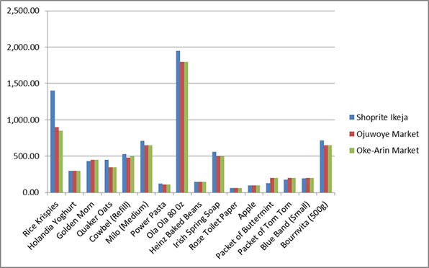

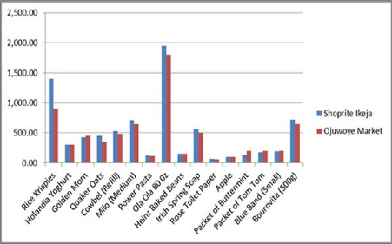**Diagram 2.1:**Comparison of Prices between Shoprite, Oke -Arin Market and Ojuwoye Market

**Diagram 2.2:**Comparison of Prices between Shoprite and Ojuwoye Market only

**CHAPTER THREE**

**3.0 SYSTEM ANALYSIS AND DESIGN**

**3.1 Analysis of the Existing System**

The current system operates manual supermarket management system, from stocks, products, ordering and purchases etc. recorded in a book. This is faced with errors, incompleteness, and insufficient data for analysis. Information regarding stocks, products, sales and purchases are still in black and white which is not properly organized and managed. From the wholesalers to retailer bills, tickets, vouchers, receipts of products are recorded in a book but further operations are not being properly handled. As a result it is difficult in processing, updating and managing.

**The factors for these difficulties are:**

**Labor-Intensive:** A manual Super Market management systems is that they can be highly labor-intensive to operate. They require continuous monitoring to ensure that each transaction is accounted for and that products are maintained at the appropriate stocking levels. It is also more difficult to share inventory information throughout the business, because the lack of computerization makes accessing inventory records a more cumbersome process. The time spent monitoring inventory levels could be used on more productive activities for the business.

**Human Error**: A manual Supermarket management system relies heavily on the actions of people, which increases the possibility of human error. People might forget to record a transaction or simply miscount the number of goods. This results in needless additional orders that increase the company's inventory carrying costs and use up precious storage space. Inaccurate physical counts could also result in not ordering enough of a product, meaning the business could run out of a crucial item at the wrong time.

**Time Wasting:**A manual Supermarket management system has a huge tendency of time wasting as the sales manager could have a lot to tackle while many customer seeks attention and this is really affecting the business.

**3.2 Description/Analysis of the New System**

To reduce the shortcomings of the existing system there is a need to develop anew system that could upgrade the status of the current system which is manual and slow to the system that will be automatic and fast. The new system should be concern with offering the requirements of the customer and the workers, the system should be reliable, easier, fast, and more informative.

The new system should possess the qualities stated below.

**Qualities of the new System**

1. Reduction in processing cost.

2. Error reduction.

3. Automatic posting.

4. Improve reporting.

5. Automatic production of the documents and Reports.

6. Faster response time.

7. Ability to meet user requirements.

8. Flexibility.

9. Reduced dependency.

10. Improves resource uses.

11. Reduction in use of the paper.

12. Reduction in Man Power.

The system is a desktop Windows application. The system will provide the following

Main features:

* Calculate the bill.
* Store how many products are sold.
* Store products and their prices and with other information.
* Change the Graphical User Interface of the system.

The System Can’t

* Print out bills
* Manage promotion

Due to the following reason:

This project is based on the sales transaction and Stocking of items in a supermarket.

**3.3 SYSTEM DESIGN**

System Design is one of the tasking sections of the Programming. In this section of the project many previews are going to be seen and we are gradually getting close to the new system. System design is a transition from a user-oriented document to a document oriented to programmers or database personnel. The system design is structured into the following parts:

* Output design
* Input design
* Database design
* System Flowchart

**3.4 Output Design**

In a very competitive world that we are, a good and attractive GUI is needed to make customers and administrators enjoy the services of a system, which would serve as a system to increase productivity in supermarket business below are previews of the output designs.

The previews of the output view of the design is shown in diagram 3.1 – 3.5

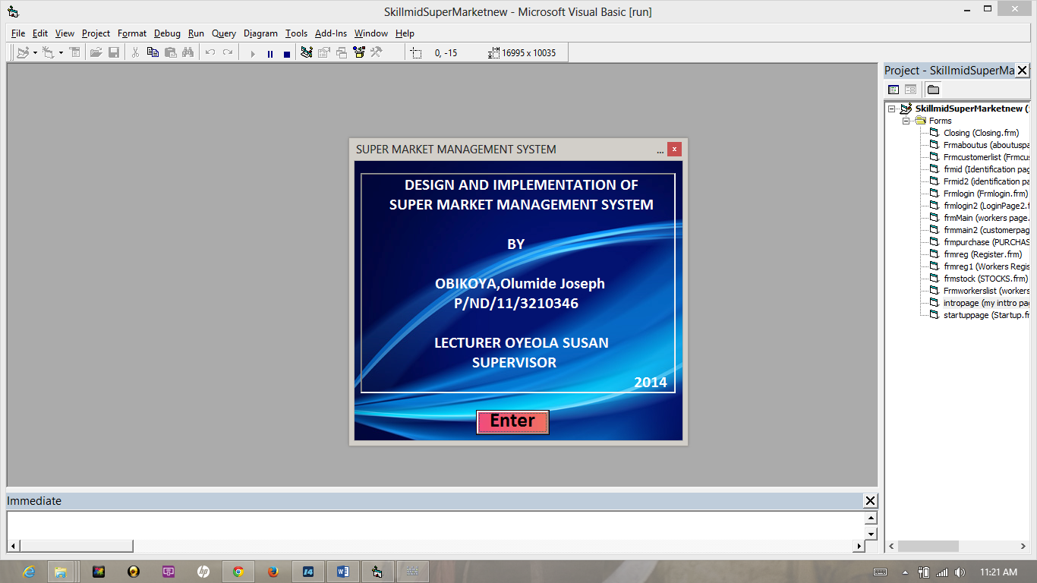

**Diagram 3.1:** Preview of Output Design to welcome Users

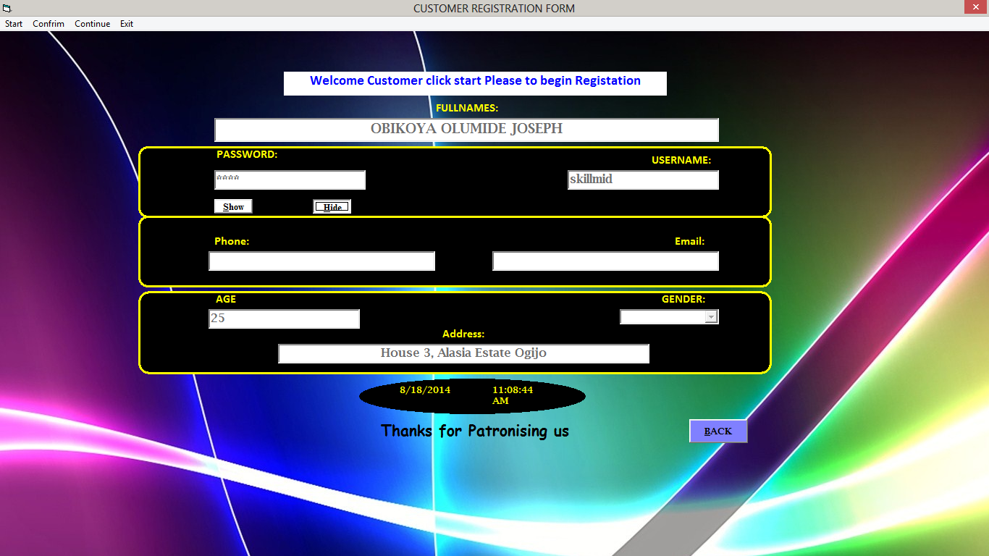

**Diagram 3.2:** Preview of Output Design to Add New Customer Details

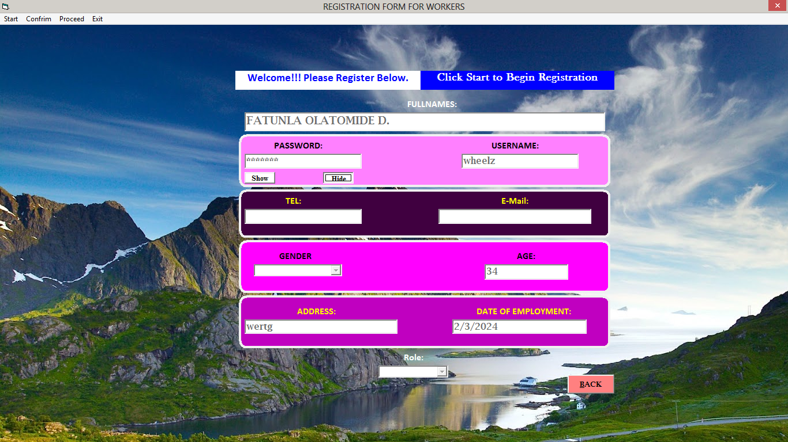

**Diagram 3.3:** Preview of Output Design to Add New Workers Details

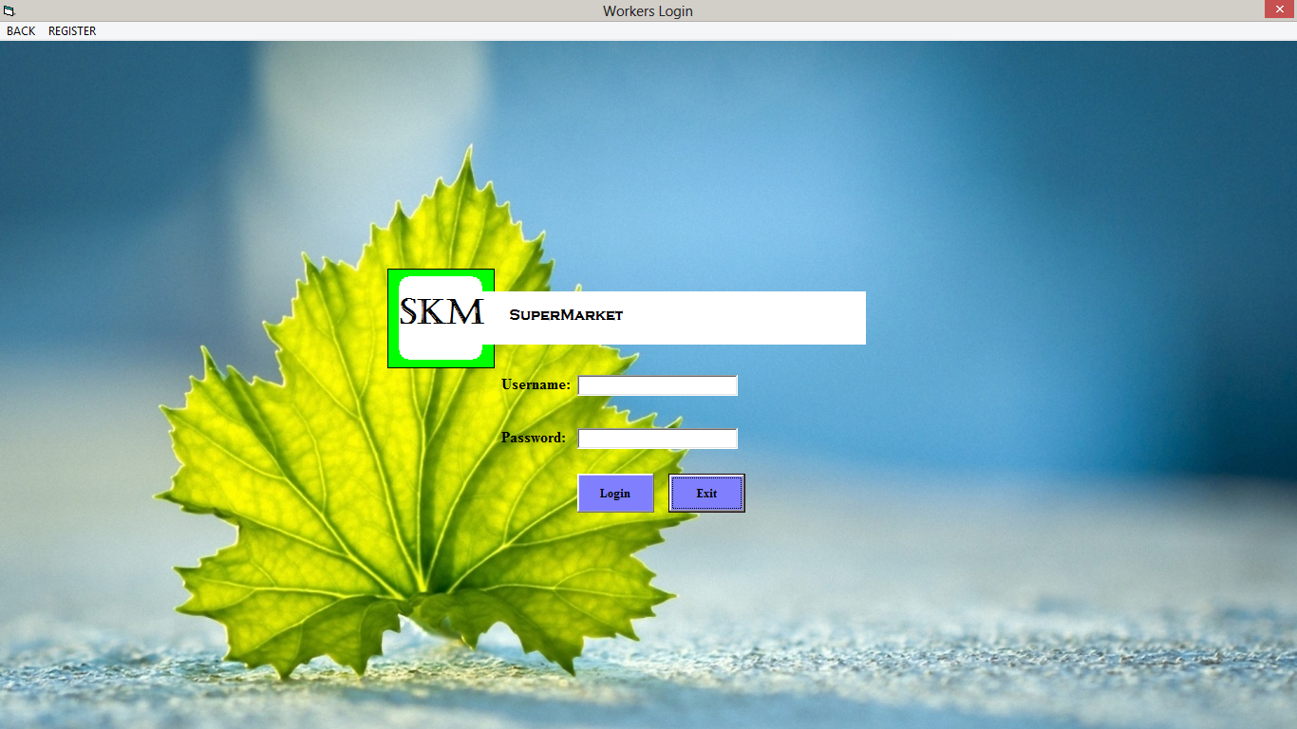

**Diagram 3.4:** Preview of Output Design for Workers Login

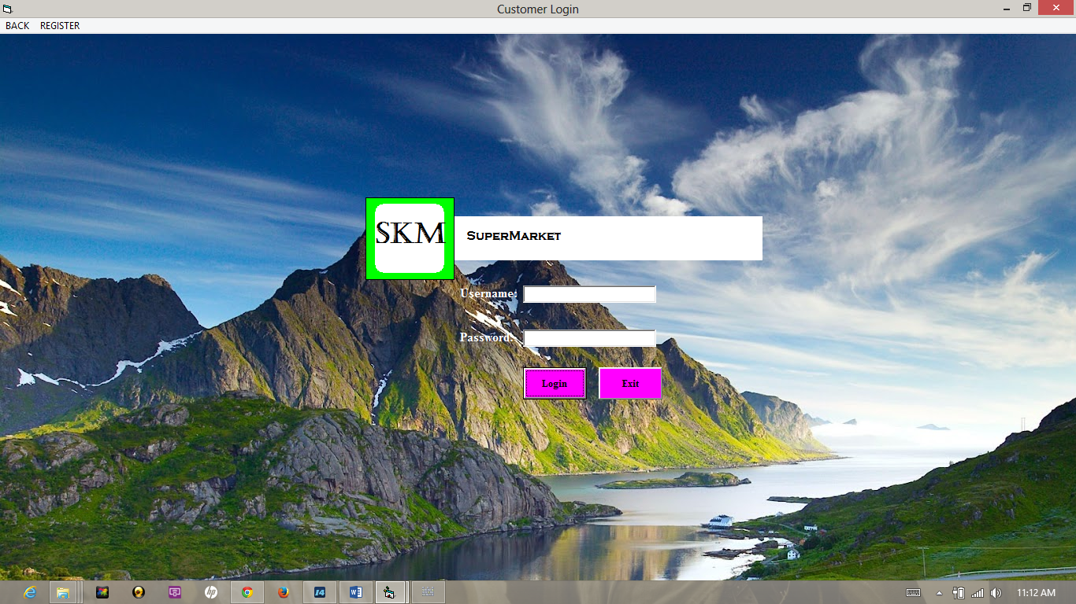

**Diagram 3.5:** Preview of Output Design for Customer Login

**3.5 Input Design**

In any organization, institution or any system of operation there is always an input into the system which keeps a system going, if the input is wrong definitely the output will be wrong. This design is meant to handle data about a particular product or stock in the Supermarkets as shown in Table 3.1- Table 3**.**3

|  |  |  |
| --- | --- | --- |
| Field Name | Data Type | Field Size |
| Full name | Long Text | 30 |
| Password | Short Text | 10 |
| Username | Short Text | 15 |
| Date of birth | Date/Time | 10 |
| Gender | Short Text | 8 |
| Address | Short Text | 10 |
| Date of Employment | Date/Time | 8 |
| Role | Short Text | 10 |

**Table 3.1:** Table for the Input Design to add new user record

|  |  |  |
| --- | --- | --- |
| Field | Data type | Field Size |
| User name | Short text | 15 |
| Password | Short text | 20 |

**Table 3.2:** Table for the Input Design to login

|  |  |  |
| --- | --- | --- |
| Field Name | Data type | Field Size |
| Product Name | Short Text | 15 |
| Product Number | Number | 2 |
| Product Quantity | Number | 2 |
| Date Received | Date | 10 |
| Description | Long Text | 40 |
| Price | Currency | 4 |
| Stocks | Number | 10 |

**Table 3.3:** Table for the Input Design to Add to the Stock

**3.6 Database Design**

Database is a file composed of records, each containing fields together with a set of operations it helps in organizing data in a logical order for references.

Database contains related data which are organized together in a group of object, table, and file. It can be in form of node. In this project a relational database concept will be used in this appraisal, related data will be store or organize in different table.

The Database design of this system is showed in diagram 3.6 – 3.9 while the system flowchart is shown in the diagram 3.10

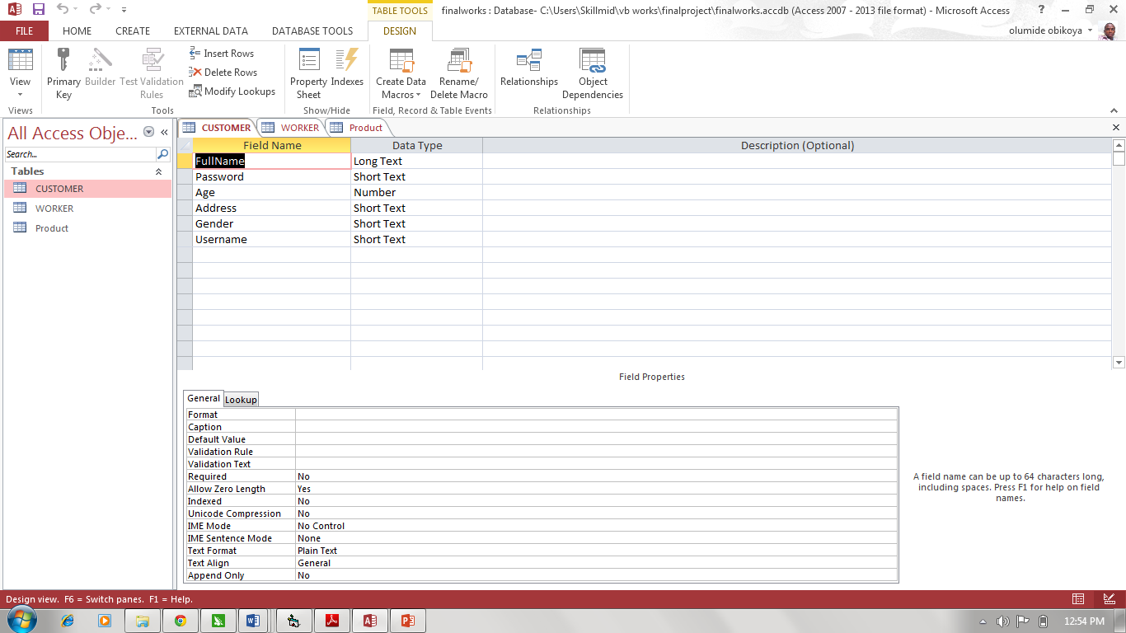

**Diagram 3.6:** Preview for Database Design for Customer

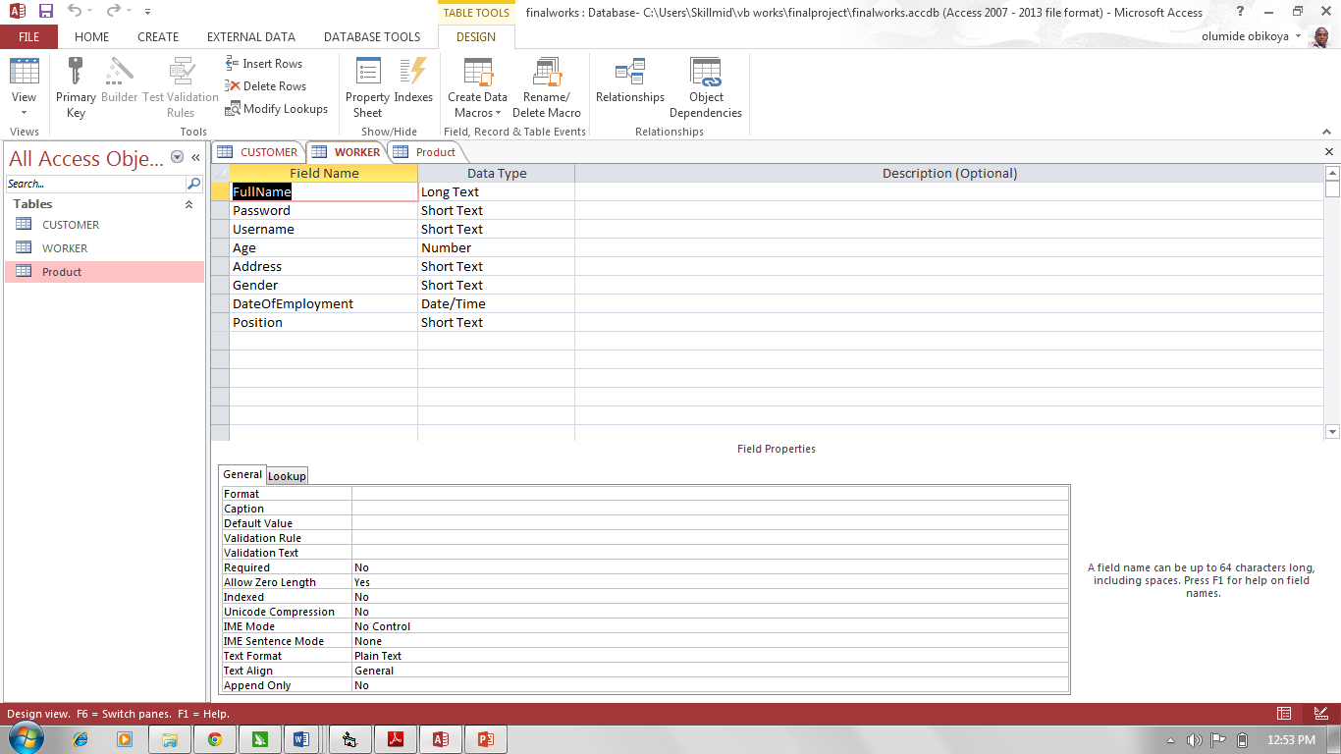

**Diagram 3.7:** Preview for Database Design for Workers

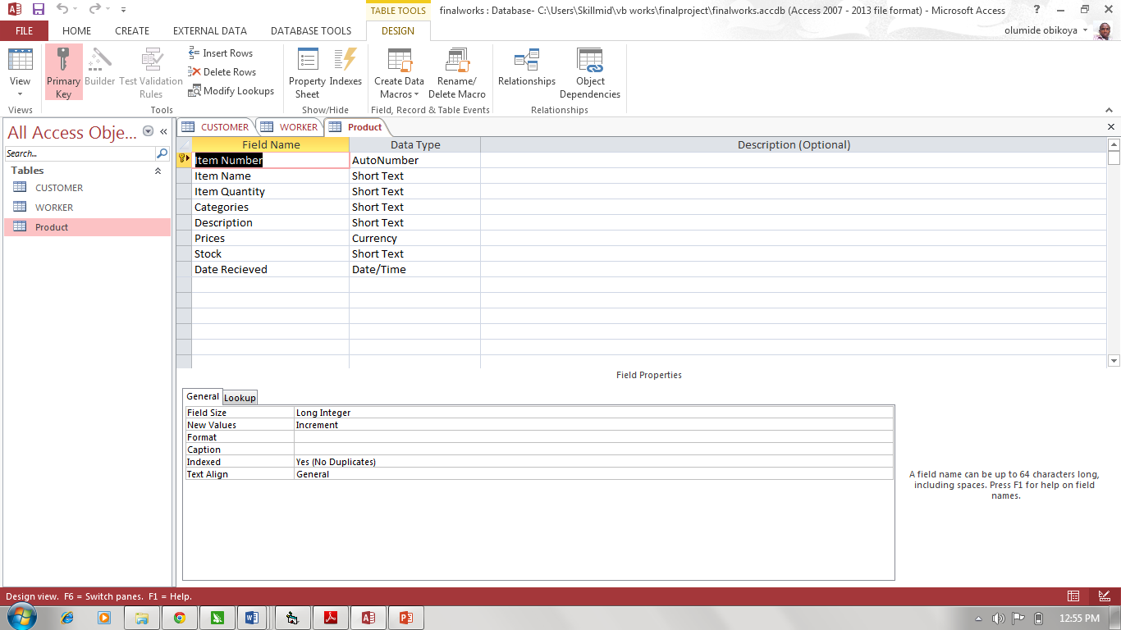

**Diagram 3.8:** Preview for Database Design for Product

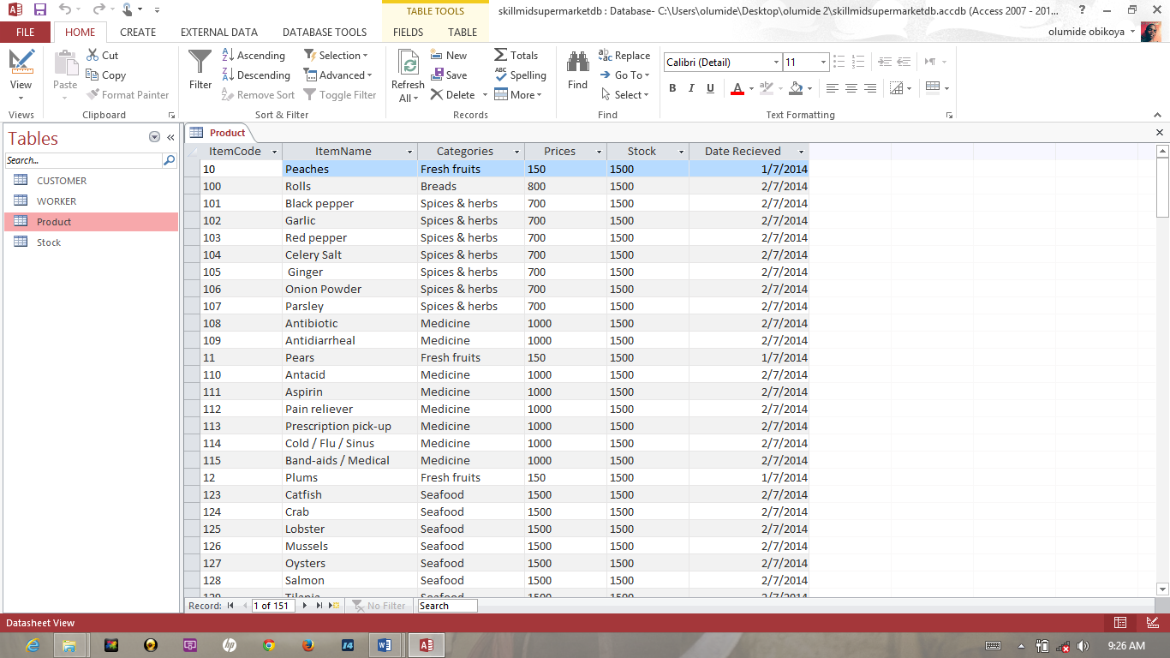

**Diagram 3.9:** Preview for Database Spreadsheet Design for Product

**3.6.4 System Flowchart**

This is the logical structure that represents the blue print of proposed system in other words, it defines as the algorithm of the software in a concise and logical order. The process design is represented diagrammatically in the form of system flow chart as shown below

Account

Account

Account

Workers/Administrator

Customer

Products

Stocks

Suppliers

Products

Items

Customer

SAVE

DELETE

CLOSE

MODIFY

Purchase Bill payments

Customer Bill Payment

Bill

**Diagram 3.10:**System Flowchart

**CHAPTER FOUR**

**4.0 SYSTEM IMPLEMENTATION AND DOCUMENTATION**

**4.1 System Implementation**

This chapter is the part that puts a planned system into action and examine in details the analysis and design of the Skillmid supermarket system. The present chapter discusses the implementation of the system, highlighting the testing exercise and describing some of the main components of the system's Graphical User Interface. It will give an output from programming language and other tools used to develop our system. According to this plan, the activities are to be carried out, discussions made regarding the equipment and resources and the additional equipment has to be acquired to implement the new system.

**4.2 Changeover Method**

This section deals with the strategy used to change from the old system to the new system. There are many methods available to swap from the old system to the new system these are direct changeover, parallel operation, pilot operation and phased operation.

I prefer a parallel operation changeover method for this system change over because this kind of method requires that both the old and the new information systems operate fully for a specified period. Data is input to both systems and output generated by the new system is compared with the equivalent output from the old system. When users, management, and IT group are satisfied that the new system (SKILLMID SUPERMAKET SYSTEM) operates correctly then the old system should be terminated. It is the most costly changeover method but it involves lower risks and it is very good.

**4.3 Hardware Specification**

For a system to be used efficiently and accurately, all [computer software](http://en.wikipedia.org/wiki/Computer_software) needs certain [hardware](http://en.wikipedia.org/wiki/Computer_hardware) components or other software resources to be present on a [computer](http://en.wikipedia.org/wiki/Computer). These prerequisites are known as (computer hardware specification) and are often used as a guideline as opposed to an absolute rule. Most software defines two sets of system requirements: minimum and recommended. With increasing demand for higher processing power and resources in newer versions of software, system requirements tend to increase over time. Industry analysts suggest that this trend plays a bigger part in driving upgrades to existing computer systems than technological advancements. A second meaning of the term of System requirements is a generalization of this first definition, giving the requirements to be met in the design of a system or sub-system. Typically an organization starts with a set of Business requirements and then derives the System requirements from there.The most common set of requirements defined by any [operating system](http://en.wikipedia.org/wiki/Operating_system) or [software application](http://en.wikipedia.org/wiki/Software_application) is the physical computer resources, also known as [hardware](http://en.wikipedia.org/wiki/Computer_hardware), A hardware requirements list is often accompanied by a [hardware compatibility list](http://en.wikipedia.org/wiki/Hardware_compatibility_list) (HCL), especially in case of operating systems. An HCL lists tested, compatible, and sometimes incompatible hardware devices for a particular operating system or application. The following sub-sections discuss the various aspects of hardware requirements for this application software

The hardware required includes the following:

* Processor 2.4 GHZ processor speed
* Disk space 80 GB (including 20 GB for database Management system)
* SVGAcolour monitor or higher quality.
* RAM 512MB.
* Backup storage hard disk of about 80MB.
* Flash drive for file transfer.
* An enhanced keyboard.
* A power stabilizer.

**4.4 Software Specification**

This are requirements specification for a [software system](http://en.wikipedia.org/wiki/Software_system), is a description of the behavior of a system to be developed and may include a set of [use cases](http://en.wikipedia.org/wiki/Use_case) that describe interactions the users will have with the software. In addition it also contains [non-functional requirements](http://en.wikipedia.org/wiki/Non-functional_requirements).

Non-functional requirements impose constraints on the design or implementation such as [performance engineering](http://en.wikipedia.org/wiki/Performance_engineering) requirements, [quality](http://en.wikipedia.org/wiki/Quality_(business)) standards

Software requirements specification establishes the basis for agreement between customers and contractors or suppliers (in market-driven projects, these roles may be played by the marketing and development divisions) on what the software product is to do as well as what it is not expected to do. Software requirements specification permits a rigorous assessment of requirements before design can begin and reduces later redesign. It should also provide a realistic basis for estimating product costs, risks, and schedules.

The software requirements specification document enlists enough and necessary requirements that are required for the project development. To derive the requirements we need to have clear and thorough understanding of the products to be developed or being developed. This is achieved and refined with detailed and continuous communications with the project team and customer till the completion of the software.

The software components used for this project are listed below:

* Operating system; Windows 98/2000/XP/Vista/7/8.
* Microsoft Visual Basic 6.0 (Front end)
* Microsoft Access(Back end)

**4.5 Choice of Programing Language**

The programming language chosen for this project is VISUAL BASIC 6.0 Visual Basic was derived from [BASIC](http://en.wikipedia.org/wiki/BASIC) and enables the [rapid application development (RAD)](http://en.wikipedia.org/wiki/Rapid_application_development) of [graphical user interface (GUI)](http://en.wikipedia.org/wiki/Graphical_user_interface)applications, access to [databases](http://en.wikipedia.org/wiki/Database) using [Data Access Objects](http://en.wikipedia.org/wiki/Data_Access_Object), [Remote Data Objects](http://en.wikipedia.org/wiki/Remote_Data_Objects), or [ActiveX Data Objects](http://en.wikipedia.org/wiki/ActiveX_Data_Object), and creation of [ActiveX](http://en.wikipedia.org/wiki/ActiveX) controls and objects. It also provides efficient back-up of data and provides adequate security.

**4.6 System Documentation**

**Installation Procedure**

This program is already packaged having its installer package some computer programs can be executed by simply copying them into a [folder](http://en.wikipedia.org/wiki/Folder_%28computing%29) stored on a computer and executing the but this is quit advanced in nature because of the advancement in technology . Other programs are supplied in a form unsuitable for immediate execution and therefore need an installation procedure. Once installed, the program can be executed again and again, without the need to reinstall before each execution.

The following are the step involve in installing Skillmid supermarket management system:

1. Install the general programming language platform.net frame work. Go to www.Microsoft.com and install the latest version of .net frame work appropriate for your computer (Windows, Mac, and Linux).

2 Copy the skillmidsupermarket database file to your Windows root folder

***Locating Root Folder.....Click on Computer....Click on Local disk c...navigate to windows......paste the file......***

3 Click on Setup

4 Follow the installation step and ignore all Prompted display

5 Go to all Program

6 Click on SkillmidSupermarket

**4.6.1 System Maintenance**

The program may be maintained on the ground that the system requires an upgrade. When there is a new field to be added or a new form to be added in other to serve users well. Though it is compiled as a standalone software the database can be tempered with but it’s advisable that the admin put a password on the file to secure the database from intrusion.

**The following precaution should be done**

* Ensure that the computer is kept in clean areas.
* System should be kept in cool places.
* Air conditioner is important to reduce room temperature and keep it constant.
* Backup of data is important

**4.6.2 SYSTEM EVALUATION**

This System is a high standard program that can weather the storm of technology advancement, it is most needed in all supermarket and it is an antidote for poor business speed and transaction with record keeping and maintenance, it will be very helpful to clients and customers in the marketing business. All it needs is a computer literate operative to make it work, it is stand alone and automated. The product will need another software if the user is willing to make print out and bills due to its restrictions.

**CHAPTER FIVE**

**5.0 Conclusion and Recommendation**

**5.1 Conclusion**

In conclusion, Supermarket Management System has to do with making appropriate effort to stop the rising problem to all manual supermarket operation in order to enhance the operation of such supermarket. In this project, the software or system that can be used to aid all supermarkets that is still operating manually have been successfully developed. The software can be implementing in all types of supermarket as mentioned in the second chapter. The software has a large memory of storing all the goods in the supermarket and also keeping record it is highly effective and accurate.

**5.2 Recommendation**

In the development of this supermarket management system, I will recommend that if there is going to be any modification the new writer should endeavor to improve on the limitations such as inclusion of the billing and printing to further increase the system architecture and to satisfy users need more for writing of the source code, visual studio 2012 should be used and Microsoft access for the database. There are some limitations during the development of this supermarket management system that will require improvement as stated in previous chapter writer should put them in mind and face it as a challenge and not a problem.

**5.3 Problem Encountered**

A lot of challenges surfaced during the development of this incredible application though it tried stopping this project but the doggedness and consistency of the writer was in match with the challenge

The following are some of the problems or challenges encountered.

* Expensive internet facility.
* Understanding the M.S ADODC (Active X Data Object Data Control).
* Inadequacy of power supply and many more.
* Time factor on research to get a way of packaging the application successively.

**5.4 Further research**

In the future, the following components can be added to the system in order to improve the effectiveness and efficiency of the system, which includes:

1. An advanced password system that will be embedded into all login pages to increase the security of the system.
2. A good Printing module should be included.
3. A good internet backup should be automated after everyday sales.
4. Internet Transactions should be allowed.

**REFERENCES/BIBLIOGRAPHY**

* <http://msdn.microsoft.com/en-us/library/aa645481(v=vs.71).aspx>
* <http://www.visualstudio.com/en-us>
* <http://support.microsoft.com/kb/2899270>
* <http://www.vbtutor.net/vb6/lesson28.html>
* <http://www.profsr.com/vb/vbless08.htm>
* <http://www.pudn.com/downloads51/sourcecode/os/detail176563.html>
* http://en.wikipedia.org/wiki/Inventory://
* www.barcodesinc.com/
* Ballou, R.H. (1999). Business Logistics Management: Planning, Organizing and Controlling the Supply Chain, 4th ed., Prentice-Hall International, London.
* Billington, C., Callioni, G., Crane, B., and Ruark, J.D., et al, (2004) “Accelerating the Profitability of HewlettPackard's”
* Supply Chains”. Interfaces. Linthicum Breugelmans, E., Campob, and K., Gijsbrechts (2006).
* “Opportunities for active stock-out management in computerized stores: The impact of the stock-out policy on computerized stock-out reactions © 2006 New York University. Published by Elsevier Inc.
* Bucklin, L.P. (1965). "Postponement, speculation, and the structure of distribution channels", Journal of Marketing Research, Vol. 2 No. 1.
* Bowersox, C. (2009). “Inventory Speculation: Cause and Effect”, Ohio, United States 89511
* Fleischmann, M., van Nunen, J.A.E.E., and Grave, B., (2003). “Integrating Closed-Loop Supply Chains and Spare-Parts Management at IBM” Interfaces.
* Linthicum: Vol.33, Iss. 6; Frazelle .E. (2009). “Supply Chain Strategy: The Logistics of Supply Chain Management”, New York,
* Monczka, R.M, Trent, RJ. AndHandfield, R.B. (2002). Purchasing and Supply Chain Management, 2nd éd., South-Western, Cincinnati, Ohio, United States.
* Pagh, J.D. and Cooper, M.C. (1998). "Supply chain postponement and speculation strategies: how to choose the right strategy", Journal of Business Logistics, Vol. 19
* Patton, M.Q. (1990). Qualitative Evaluation and Research Methods, 2nd edition, New Bury Park, CA.
* Rietze, S. (2008). “Examination of supply response”, WA 98237, Vol 7.
* Seuring, S. (2011), “Supply chain management for sustainable products – insights from research applying mixed methodologies”, Cleveland, OH 44106 Vol. 11.
* Wallin, C., Rungtusanatham, M.J., and Rabinovich, E (2006). “What is the "right" inventory management approach for a purchased item?” International Journal of Operations & Production Management.
* Yang, B., and Burns, N.D. (2003). "Implications of postponement for the supply chain", International Journal of Production Research, Vol. 41 No.9.

**Appendix**

**Coding for Customer Registration Form**

Private Sub Command1_Click ()

Me.Hide

frmid.Show

End Sub

Private Sub confrim_Click ()

If Text1.Text = "" Or Text2.Text = "" Or Text3.Text = "" Or Text4.Text = "" Or Text5.Text = "" Or Text6.Text = "" Then

frmreg.Show

MsgBox "Please, Fill all Details Customer"

Else

reg1.Recordset.Update

MsgBox "Record Saved", vbInformation, "Save"

MsgBox ("Thanks for Registering, click continue to log in")

Frmlogin.Show

End If

End Sub

Private Sub exit_Click ()

If MsgBox ("Are you sure you want to quit?", vbYesNo) = vbYes Then

End

End If

End Sub

Private Sub Form_Load ()

Combo1.AddItem "Male"

Combo1.AddItem "Female"

Text1.Enabled = False

Text2.Enabled = False

Text3.Enabled = False

Text4.Enabled = False

Text4.Enabled = False

Combo1.Enabled = False

Text6.Enabled = False

lblDate.Caption = Date

lblTime.Caption = Time

End Sub

Private Sub Option1_Click ()

If Option1.Value = True Then Text2.PasswordChar = ""

End Sub

Private Sub Option2_Click ()

If Option2.Value = True Then Text2.PasswordChar = "*"

End Sub

Private Sub Proceed_Click ()

Unload Me

reg1.Recordset.Update

Frmlogin.Show

End Sub

Private Sub start_Click ()

If Text1.Text = "" Or Text2.Text = "" Or Text3.Text = "" Or Text4.Text = "" Or Text5.Text = "" Or Text6.Text = "" Then

frmreg.Show

Else

reg1.Recordset.AddNew

Text1.Enabled = True

Text2.Enabled = True

Text3.Enabled = True

Text4.Enabled = True

Text5.Enabled = True

Text7.Enabled = True

Combo1.Enabled = True

Text6.Enabled = True

Text1.Text = ""

Text2.Text = ""

Text3.Text = ""

Text4.Text = ""

Text4.Text = ""

Combo1.Text = ""

Text6.Text = ""

End If

End Sub

Private Sub Text1_Change ()

Text1.Text = UCase (Text1.Text)

Text1.SelStart = Len (Text1.Text)

End Sub

Private Sub Timer1_Timer ()

lblDate.Caption = Date

lblTime.Caption = Time

End Sub

**Coding for Workers Registration Form**

Private Sub Command1_Click()

Me.Hide

frmid.Show

End Sub

Private Sub Command2_Click ()

Text1.Text = ""

Text2.Text = ""

Text3.Text = ""

Text4.Text = ""

Text5.Text = ""

Text6.Text = ""

Text7.Text = ""

Text8.Text = ""

Combo3.Text = ""

Combo2.Text = ""

End Sub

Private Sub confrim_Click ()

If Text1.Text = "" Or Text2.Text = "" Or Text3.Text = "" Or Text4.Text = "" Or Text5.Text = "" Or Text6.Text = "" Then

frmreg1.Show

MsgBox "Please Fill all Details Worker it is Required."

Else

reg2.Recordset.Fields ("FullName") = Text1.Text

reg2.Recordset.Fields ("Password") = Text2.Text

reg2.Recordset.Fields ("Username") = Text3.Text

reg2.Recordset.Fields ("Age") = Text4.Text

reg2.Recordset.Fields ("Address") = Text5.Text

reg2.Recordset.Fields ("DateOfEmployment") = Text6.Text

reg2.Recordset.Fields ("Phonenumber") = Text7.Text

reg2.Recordset.Fields ("Email") = Text8.Text

reg2.Recordset.Fields ("Age") = Text4.Text

reg2.Recordset.Fields ("Gender") = Combo2.Text

reg2.Recordset.Fields ("Position") = Combo3.Text

reg2.Recordset.Update

MsgBox "Record Saved", vbInformation, "Save"

MsgBox ("Thanks for Registering,click ok to log in")

frmlogin2.Show

Unload Me

End If

End Sub

Private Sub exit_Click ()

If MsgBox ("Are you sure you want to quit?", vbYesNo) = vbYes Then

End

End If

End Sub

Private Sub Form_Load ()

Combo3.AddItem "Admin"

Combo3.AddItem "Stock Manager"

Combo3.AddItem "Sales Manager"

Combo3.AddItem "Record Keeper"

Combo3.AddItem "Others"

Combo2.AddItem "Male"

Combo2.AddItem "Female"

Text1.Enabled = False

Text2.Enabled = False

Text3.Enabled = False

Text4.Enabled = False

Text5.Enabled = False

Text6.Enabled = False

Text7.Enabled = False

Text8.Enabled = False

Combo3.Enabled = False

Combo2.Enabled = False

Command2.Enabled = False

confrim.Enabled = False

End Sub

Private Sub Option1_Click ()

If Option1.Value = True Then Text2.PasswordChar = ""

End Sub

Private Sub Option2_Click ()

If Option2.Value = True Then Text2.PasswordChar = "*"

End Sub

Private Sub Proceed_Click ()

Unload Me

frmlogin2.Show

End Sub

Private Sub start_Click ()

If Text1.Text = "" And Text2.Text = "" And Text3.Text = "" And Text4.Text = "" And Text5.Text = "" And Text6.Text = "" Then

frmreg1.Show

Else

Text1.Enabled = True

Text2.Enabled = True

Text3.Enabled = True

Text4.Enabled = True

Text5.Enabled = True

Text6.Enabled = True

Text7.Enabled = True

Text8.Enabled = True

Combo3.Enabled = True

Combo2.Enabled = True

Command2.Enabled = True

confrim.Enabled = True

Text1.Text = ""

Text2.Text = ""

Text3.Text = ""

Text4.Text = ""

Text5.Text = ""

Text6.Text = ""

Text7.Text = ""

Text8.Text = ""

Combo3.Text = ""

Combo2.Text = ""

End If

End Sub

Private Sub Text1_Change ()

Text1.Text = UCase (Text1.Text)

Text1.SelStart = Len (Text1.Text)

End Sub

**Coding for Customer Login Form**

Private Sub BACK_Click ()

Me.Hide

Frmid2.Show

End Sub

Private Sub Command1_Click ()

If Text1.Text = "" And Text2.Text = "" Then

MsgBox "Input your Password and Username"

Text1.Text = "username"

Text2.Text = "password"

End If

With reg1.Recordset

.Filter = "Username = '" & Text1.Text & "' and Password = '" & Text2.Text & "'"

If .RecordCount> 0 Then

MsgBox "Access Granted: " & .Fields ("FullName"), vbInformation, "Login"

frmmain2.Show

Unload Me

Else

MsgBox "Invalid Account, Register to gain access", vbCritical, "Login" '

Text1.Text = ""

Text2.Text = ""

Text1.SetFocus

End If

End With

End Sub

Private Sub Command2_Click ()

If MsgBox ("Are you sure you want to quit now?” vbYesNo) = vbYes Then

End

End If

End Sub

Private Sub Form_Load ()

If Text1.Text = "" And Text2.Text = "" Then

Command1.Enabled = False

End If

End Sub

Private Sub REGISTER_Click ()

Me.Hide

frmreg.Show

End Sub

Private Sub Text1_Change ()

Command1.Enabled = True

End Sub

Private Sub Text2_Change ()

Command1.Enabled = True

End Sub

**Coding for Workers Login Form**

Private Sub BACK_Click ()

Me.Hide

Frmid2.Show

End Sub

Private Sub Command1_Click ()

If Text1.Text = "" And Text2.Text = "" Then

MsgBox "Input your Password and Username"

Text1.Text = "username"

Text2.Text = "password"

End If

With reg2.Recordset

.Filter = "Username = '" & Text1.Text & "' and Password = '" & Text2.Text & "'"

If .RecordCount> 0 Then

MsgBox "Access Granted: " & .Fields ("FullName"), vbInformation, "Login"

frmMain.Show

Unload Me

Else

MsgBox "Invalid Account, Register to gain access", vbCritical, "Login" '

Text1.Text = ""

Text2.Text = ""

Text1.SetFocus

End If

End With

End Sub

Private Sub Command2_Click ()

If MsgBox ("Are you sure you want to quit now?", vbYesNo) = vbYes Then

End

End If

End Sub

Private Sub Form_Load ()

If Text1.Text = "" And Text2.Text = "" Then

Command1.Enabled = False

End If

End Sub

Private Sub Text1_Change ()

Command1.Enabled = True

End Sub

Private Sub Text2_Change ()

Command1.Enabled = True

End Sub

Private Sub REGISTER_Click ()

Me.Hide

frmreg1.Show

End Sub

**Coding for Purchase Form**

Private Sub Command1_Click ()

Text2.Text = Val (Combo1.Text) * Val (Text1.Text)

End Sub

Private Sub Command10_Click ()

Text19.Text = Val (Combo10.Text) * Val (Text20.Text)

End Sub

Private Sub Command11_Click ()

Text22.Text = Val (Combo11.Text) * Val (Text21.Text)

End Sub

Private Sub Command12_Click ()

Text24.Text = Val (Combo12.Text) * Val (Text23.Text)

End Sub

Private Sub Command13_Click ()

Text26.Text = Val (Combo13.Text) * Val (Text25.Text)

End Sub

Private Sub Command14_Click ()

Text27.Text = Val(Text2.Text) + Val(Text3.Text) + Val(Text5.Text) + Val(Text7.Text) + Val(Text9.Text) + Val(Text11.Text) + Val(Text13.Text) + Val(Text15.Text) + Val(Text17.Text) + Val(Text19.Text) + Val(Text22.Text) + Val(Text24.Text) + Val(Text26.Text)

End Sub

Private Sub Command15_Click ()

If MsgBox ("Have you finished Purchasing you product?", vbYesNo) = vbYes Then

Closing.Show

End If

End Sub

Private Sub Command16_Click ()

Unload Me

frmmain2.Show

End Sub

Private Sub Command2_Click ()

Text3.Text = Val (Combo2.Text) * Val(Text4.Text)

End Sub

Private Sub Command3_Click ()

Text5.Text = Val (Combo3.Text) * Val (Text6.Text)

End Sub

Private Sub Command4_Click ()

Text7.Text = Val (Combo4.Text) * Val (Text8.Text)

End Sub

Private Sub Command5_Click ()

Text9.Text = Val (Combo5.Text) * Val (Text10.Text)

End Sub

Private Sub Command6_Click ()

Text11.Text = Val (Combo6.Text) * Val (Text12.Text)

End Sub

Private Sub Command7_Click ()

Text13.Text = Val (Combo7.Text) * Val (Text14.Text)

End Sub

Private Sub Command8_Click ()

Text15.Text = Val (Combo8.Text) * Val (Text16.Text)

End Sub

Private Sub Command9_Click ()

Text17.Text = Val (Combo9.Text) * Val (Text18.Text)

End Sub

Private Sub DataCombo1_Change ()

Text1.Text = "150"

End Sub

Private Sub DataCombo10_Change ()

Text20.Text = "1500"

End Sub

Private Sub DataCombo11_Change ()

Text21.Text = "2000"

End Sub

Private Sub DataCombo12_Change ()

Text23.Text = "700"

End Sub

Private Sub DataCombo13_Click (Area As Integer)

Text25.Text = "1500"

End Sub

Private Sub DataCombo2_Change ()

Text4.Text = "1500"

End Sub

Private Sub DataCombo3_Change ()

Text6.Text = "250"

End Sub

Private Sub DataCombo4_Change ()

Text8.Text = "200"

End Sub

Private Sub DataCombo5_Change ()

Text10.Text = "1000"

End Sub

Private Sub DataCombo6_Change ()

Text12.Text = "1500"

End Sub

Private Sub DataCombo7_Change ()

Text14.Text = "800"

End Sub

Private Sub DataCombo8_Change ()

Text16.Text = "700"

End Sub

Private Sub DataCombo9_Change ()

Text18.Text = "1000"

End Sub

Private Sub Form_Load ()

lblDate.Caption = Date

lblTime.Caption = Time

DataCombo13.Text = ""

End Sub

Private Sub Timer1_Timer ()

lblDate.Caption = Date

lblTime.Caption = Time

End Sub

Private Sub worker_Click ()

frmlogin2.Show

MsgBox ("Accurately work on stocks Reduction Please")

End Sub

**Coding for Stock Form**

Private Sub Command1_Click ()

Unload Me

frmmain2.Show

End Sub

Private Sub Command2_Click ()

If MsgBox("THANKS FOR CHECKING OUR STOCKS WE REALLY APPRECIATE YOU, PLEASE DO PURCHASE OUR STOCK by clicking NO now then click Purchase, otherwise click Yes, have a Splendid day.", vbYesNo, "Are You Leaving So Soon") = vbYes Then

End

End If

End Sub

Private Sub Command3_Click ()

Unload Me

frmpurchase.Show

End Sub

Private Sub Command6_Click ()

If Option1.Value = True Then

If Not txtSearch.Text = "" Then

Stock.Recordset.Filter = "ItemName like '%" &txtSearch.Text& "%'"

Else

Stock.Refresh

MsgBox ("Sorry Item not available in Stock")

End If

Else

If Not txtSearch.Text = "" Then

Stock.Recordset.Filter = "Categories like '%" &txtSearch.Text& "%'"

Else

Stock.Refresh

MsgBox ("Sorry Item not available in Stock")

End If

End If

End Sub

**Coding for Customer list Form**

Private Sub Command1_Click ()

Unload Me

frmMain.Show

End Sub

Private Sub Command3_Click ()

If MsgBox ("Are you sure?” vbQuestion + vbYesNo, "Delete Record") = vbYes Then

reg1.Recordset.Delete

MsgBox "Record Deleted", vbInformation, "Delete"

End If

End Sub

Private Sub Command6_Click()

If Option1.Value = True Then

If Not txtSearch.Text = "" Then

reg1.Recordset.Filter = "Fullname like '%" &txtSearch.Text& "%'"

Else

reg1.Refresh

End If

Else

If Not txtSearch.Text = "" Then

reg1.Recordset.Filter = "Gender like '%" &txtSearch.Text& "%'"

Else

reg1.Refresh

End If

End If

End Sub

**Coding for Workers list Form**

Private Sub Command1_Click ()

Unload Me

frmMain.Show

End Sub

Private Sub Command3_Click()

If MsgBox("Are you sure?", vbQuestion + vbYesNo, "Delete Record") = vbYes Then

reg2.Recordset.Delete

MsgBox "Record Deleted", vbInformation, "Delete"

End If

End Sub

Private Sub Command6_Click()

If Option1.Value = True Then

If Not txtSearch.Text = "" Then

reg2.Recordset.Filter = "Fullname like '%" &txtSearch.Text& "%'"

Else

reg2.Refresh

End If

Else

If Not txtSearch.Text = "" Then

reg2.Recordset.Filter = "Gender like '%" &txtSearch.Text& "%'"

Else

reg2.Refresh

End If

End If

End Sub